Leveling the heating platform

1. Why leveling is so important

If the distance between the heating plate and the nozzle is too long, or if there is no leveling, resulting in the distance between the heating platform and the nozzle is too far or too close, then it will easily cause the condition of the non-stick.

If the heating plate is close to the nozzle, the heating plate will directly affect the filament out from the nozzle , which may also cause the heating plate to be scratched.

Leveling the heating plate before printing helps ensure that the printed object is adhered to the heating plate.

2. How to level the heating plate

The height of the heating plate can be adjusted by turning the three screws under the plate.

Tighten the screws [tighten counterclockwise] to increase the distance between the heating plate and the nozzle.

Loosen the screw [turn clockwise] and the heater plate will be close to the nozzle.

Please control the distance between the nozzle and the heater plate to the thickness of a sheet of A4 paper.

Specific operation method

**一、 auto-home**

The user can directly enter the operation option page on the LCD screen, select “Prepare”, and then select “Auto home”.

**二、adjust the distance**

After the auto-home is completed, you can directly disconnect the power supply and USB data cable, manually move the nozzle to change the position of the nozzle on the platform, or you can change the position of the extruder through XY displacement of the screen or software. Observe three corner positions of the nozzle and platform and adjust the distance.

After the machine finish the auto- home, it is possible to further adjust the height of the heating plate by turning the three screws under the plate. When you adjust each screw, make sure that the distance between the heater plate and the nozzle is the distance that an A4 paper can travel. You can feel that the nozzle has a little rubbing against the A4 paper, but still can pass without scratching.

Correct distance between nozzle and base plate:

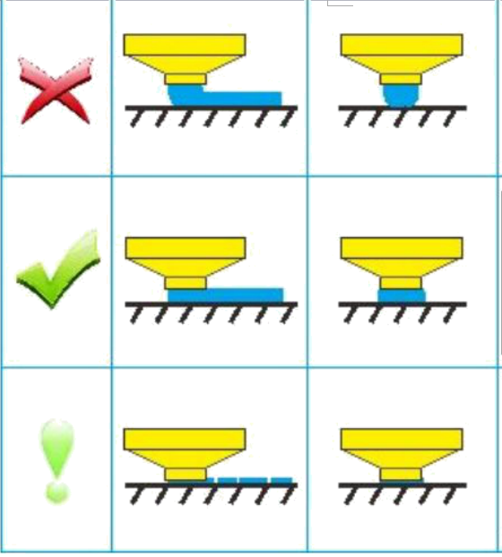

Start 3D printing after platform debugging